

**Monetary Policy and Debt Sustainability**

Speech given by

Kate Barker, Member of the Monetary Policy Committee, Bank of England

Meeting of the West Cheshire and North Wales Chamber of Commerce 23 September 2009

I would like to thank Matthew Corder, Charlotta Groth and Jake Horwood for research assistance, and others for helpful comments. The views expressed are my own and do not necessarily reflect those of the Bank of England or other members of the Monetary Policy Committee.

1

All speeches are available online at [www.bankofengland.co.uk/publications/Pages/speeches/default.aspx](http://www.bankofengland.co.uk/publications/Pages/speeches/default.aspx)

# Introduction

It is a great pleasure to have the opportunity to talk to the West Cheshire and North Wales Chamber of Commerce today. No part of the UK has been able to avoid the impact of the present recession, and I am aware that this area is no exception, in particular experiencing the effects of the sharp downswing in the automotive sector. And in the service sector, the anecdotal evidence suggests that the strength hoped for in tourism, supported by weak sterling, has so far proved somewhat disappointing here.

As the economy moves through the financial crisis, the Monetary Policy Committee is faced with a complex set of issues. I have been considering two separate, although related, questions. These are: how quickly, and how strongly, will the UK economy recover over the next year or so? And: what are the likely implications of the present financial crisis for the way in which the economy will develop in the medium-term? I will say a little about the short-term outlook first, but intend to spend more time on the second question. In looking at the medium-term outlook, I will be responding to the frequent criticism that over the period prior to the start of the credit crisis in the summer of 2007, debt levels, particularly for households, had been permitted to reach clearly unsustainable levels. These remarks look at the question of debt sustainability from a variety of perspectives, leading on to some reflections on how balance sheet adjustments may affect the economic outlook, and the possible implications for monetary policy.

# Short-term outlook

The overall flow of economic data in recent months has been positive. After a fall of 2.5% in the first quarter of 2009, GDP in the euro area fell just 0.1% in the second. Industrial production in much of Asia is staging a strong comeback from the very sharp falls around the turn of the year. Equity prices have continued to strengthen in the US, EU and UK. In the UK, while GDP fell 0.7% in the second quarter the main business surveys have continued to be encouraging, the housing market has been strengthening, and consumer confidence has recovered a little more.

However, it is still unclear that this rate of improvement will be maintained into the autumn. Some of the recovery in manufacturing, in the UK and elsewhere, reflects a less rapid pace of destocking, and special support for the automotive industry has supported demand and output in that sector. As these positive factors fade there is a risk that the pace of recovery may falter, and the path of output could be quite uneven over coming quarters.

Some indicators have been less encouraging. Business investment was 14% lower in the first half of 2009 than the same period in 2008 (although these early estimates are often significantly revised). Total finance to the corporate sector remains weak, reflecting trends in bank lending, even though higher corporate bond issuance suggests some firms have been successful in diversifying their sources of finance. And the expected further increases in unemployment over coming quarters, combined with tighter credit conditions, may well check the housing market. Survey data over the next few months will give a clearer picture of how economic momentum is being maintained into the autumn.

Inflation has recently tended to come in a little higher than expected. In the second quarter of 2009, CPI inflation was more than 0.5 percentage points higher than the central projection in the February *Inflation Report.* In part this may reflect a more rapid pass-through of the weaker exchange rate to consumer prices, although this is perhaps surprising at a time of falling output. Looking ahead, however, the present weak nominal wage growth (private sector wages, excluding bonuses, was up just 2.2% on a year earlier in the three months to July) suggests downward pressure on inflation as unit labour costs growth may well be very weak when output starts to pick up.

I strongly supported the move to introduce quantitative easing earlier in the year, not least as at the time the risk of a major downward spiral in the economy seemed high if nothing further were done to bolster confidence and nominal demand. There remains considerable uncertainty about the precise impact of this policy, but there is now evidence of its positive impact on the economy: including the downward pressure on gilt yields and lower corporate bond spreads and better liquidity in that market. While bank lending has not yet picked up, it is important to be aware of the variety of channels through which this policy may work. More generally, the whole set of fiscal and monetary easing in the UK and globally has bolstered confidence and reduced, but not eliminated, the downside risk. But even if the UK economy starts to grow again in the latter part of this year, it may be several quarters before growth is strong enough to reduce the present significant extent of excess capacity. And looking further ahead, the medium-term outlook may increasingly be affected by the various pressures now apparent on the debt levels of the different sectors in the economy.

# Debt sustainability

Comments about debt levels being unsustainable are often made without much clarity about how this judgement has been reached. Different approaches to sustainability can be distinguished. The financial position of a government is deemed to be unsustainable if, given the starting level of debt, the prospects for the real interest rate on government debt and for GDP growth imply that the debt/GDP ratio will be on an ever-rising trend1. Similarly, for a household or firm the burden of debt is in some sense unsustainable if expected income growth, the likely path of interest rates and maintenance of current spending patterns imply ever-rising debt levels. This might be thought of as a weak form of sustainability.

Whether in practice the financial position of an individual household or firm turns out to be sustainable will depend on whether their original assumptions prove reasonably accurate. It is not surprising that for some, this will prove not to be the case, and they will be forced into some form of insolvency if they do not adjust in some way. And the proportion of households and firms in this situation is likely to rise in recessions – but it would be a high hurdle for overall debt sustainability that meant no borrower suffered in a severe downturn.

A stronger form of sustainability would relate to a level of debt that households or firms wanted to sustain (ie under plausible assumptions it was unlikely to lead to ever-rising debt levels *and* agents were comfortable with the steady-state level of debt). This could lead to a higher level of debt than is desired with hindsight. This could be because of an unexpectedly large shock to income growth, or to interest rates, or because their perception of risk was altered significantly.

The discussion below considers the recent build up of debt in the UK economy in relation to these different forms of sustainability. It also looks at the sustainability of the UK’s current account position, and at the prospects for an improvement in the current account to play a role in the overall adjustments likely between different sectors in the economy. I am not here going to address the question of whether some financial institutions themselves were over-extended in the UK market, although in commenting on the outlook for debt, there may well be constraints on the supply of, as well as the demand for, credit.

Looking first at financial balances, the most obvious point is that large imbalances between the main sectors are quite frequent (Chart One). The overall picture during the first decade of the MPC was that

1 The government’s solvency condition implies that, if real bond yields are above GDP growth, the government will need to run a surplus before allowing for debt interest payments.

the household sector was generally in deficit, while the public sector has moved from surplus to growing deficit, offset largely but not entirely by a corporate sector surplus. The sum result was a persistent current account deficit, which increased in the mid-2000s. The last two years have then brought major changes, with the public sector balance deteriorating rapidly, and the household and corporate sectors both improving. The overall corporate sector surplus however is somewhat misleading, as it is partly driven by a recent, erratic improvement from the financial sector (Chart Two).2

These financial flow positions however only tell part of the story, as changes in balance sheets, driven by asset values, will also affect the willingness and ability to acquire debt. Since the start of the present financial crisis in late summer 2007, falls in asset prices have led to a sharp deterioration in the balance sheets of the household sector, and of the corporate sector on a market cost basis (Charts Three and Four). But in judging the vulnerability of these sectors, the distribution of debt and assets also matters, since frequently these are held by different people or firms, and cannot simply be offset.

# The Household Sector

The financial crisis has adversely affected the household sector’s wealth, and is also likely to have affected household expectations of income growth and the cost of debt. Capital gearing (the ratio of gross debt to household wealth) reached 22% in the first quarter of 2009, the highest since this series started in 1987. And the burden of debt servicing (the proportion of household income spent on interest payments and repayments of mortgage principal) remains relatively high compared to the average of the past 20 years, even though it has recently declined reflecting the reductions in Bank Rate (Chart Five).

Past experience suggests that households do not respond very much, at least in the short-term, to changes in capital gearing. For example, capital gearing picked up rapidly in 2001/02 as equity prices fell, but there was only a modest reduction in the growth rate of household consumption. Chart Six indicates that the rise in capital gearing in 2001 was primarily due to slower growth in asset prices, rather than faster growth of debt, and that households did not respond by adjusting their overall debt level downward. The asset price falls themselves were then concentrated in equities, rather than in housing, which perhaps accounts for the limited response. Over 60% of household equity wealth is held indirectly, through insurance companies and pension funds, and the impact of changes is therefore less transparent to the affected household. In the latest cycle, however, the fall in asset prices has been more marked, and the declines in housing wealth have played a more significant role.

2 This reflects growth in net foreign direct investment (FDI) income which was largely attributed to substantial losses of foreign-owned bank branches and subsidiaries in the UK rather than to improved profits from UK FDI.

While it is not clear that households target a particular level of wealth, it is worth considering whether present wealth levels look adequate to meet households’ expected needs. Khoman and Weale3 looked at 2004/05 wealth levels and concluded that these were more than adequate to enable each age cohort of households to meet likely consumption and income plans. Since then (Chart Seven) wealth levels rose further before returning to around the 2004 levels – so on that basis there is no reason to expect households to seek to repair wealth levels. Indeed, it is possible that households disregard fluctuations in wealth levels to some extent, particularly those which reflect changes in asset prices driven by interest rate changes. The exception might be the impact of house prices changes on consumption due to collateral effects. In addition, it is difficult for households to make very much impact on their level of wealth by changing their savings behaviour, since savings flows are small relative to wealth levels (gross wealth in 2008 was over 800% of household incomes).

Concerns about sustainability seem more plausibly related to debt, the burden of interest payments and the availability of credit rather than to attempts to rebuild wealth levels. For the sector as a whole, debt has been rising sharply relative to income over the past decade (Chart Eight). Clearly this debt expansion has to reach some limit and in that sense household behaviour was not sustainable in the long- term. The aggregate figures conceal different positions for different groups of households, although data limitations make it problematic to gain a clear picture. Charts Nine and Ten show recent changes in debt to income ratios, and average debt levels per household, for different age-groups.4 The overall indication, although there is some volatility, is that both absolute debt levels and debt/income ratios have been rising for the core age-group from 25 to 55.

However, the fact that debt has been rising relative to income does not mean that the *level* of debt itself is unsustainable. Indeed, prior to the financial crisis is could be argued that much of the rise in debt levels could be explained by a combination of the lower level of real interest rates pushing up house prices, and greater confidence in the stability of the UK economy and therefore a lesser probability of long periods of unemployment5. But there are factors suggesting that an increasing part of the debt build-up, especially in the recent past, was unsustainable in the sense that the underlying assumptions were simply not realistic.

3 Khoman and Weale (2006). This article also argued that the overall level of national savings was insufficient.

4 Drawn from the NMG survey, which has a sample size of around 2000.

5 Discussed in Nickell (2005); reasons for the fall in savings in the mid-2000s, associated with higher debt although not necessarily implied by it, are discussed in Berry, Waldron and Williams (2009)

These would include part of the rise in unsecured loans for some households (based on unrealistic expectations of individual incomes) and some mortgages (particularly latterly for some buy-to-let mortgages based on hopes of ever-rising house prices). These factors have contributed to an increase in individual insolvencies to a peak of over 33,000 in England and Wales in the second quarter of 2009.

More generally, there was a misperception of risk, towards the end of the long period of economic stability. Unemployment is expected to rise further in coming quarters, adding to pressure on many households, and increasing concern for individuals that it will be more difficult to move back into employment in the event of redundancy. Households may well now have an increased perception of risk related to their incomes as unemployment has risen.

In addition, households may be concerned over higher than expected debt interest payments relative to income. Relative to previous expectations, the recession will have reduced the expected level of household incomes over the coming years. Even prior to the financial crisis, signs of pressure were apparent in the rising proportion of income taken by mortgage payments for first-time buyers and overall above-average income gearing. At present, the low level of Bank Rate is tending to reduce immediate pressure from this source. But households will be aware that borrowing spreads have risen as financial institutions have widened the spread between borrowing and lending rates in response to their changed appreciation of risk. While Bank Rate has fallen by 5.25 percentage points since the start of the crisis, the effective mortgage rate has only fallen by 1.6 percentage points to 4.2% on new mortgages, and by 2.3 percentage points to 3.6% on the outstanding stock of mortgages.

Households may well anticipate that Bank Rate will return to a higher level in coming years, which, if lending spreads remain elevated as at present, could push household gearing up sharply. But in this context it is important to remember that the MPC will be aware of the higher spreads, so, other things being equal, the level of Bank Rate consistent with the inflation target would tend to be lower.

Lastly, greater caution by lending institutions, with higher deposits and lower loan-to-value ratios for mortgages, will reduce the ability of some households to take on debt.

The rate of growth of household debt has recently slowed sharply: net lending to individuals rose by only 0.9% in twelve months to July and there was a small net repayment of debt in July itself. The

overall level of debt was not necessarily far above sustainable prior to the financial crisis, given that many households would probably be able to sustain a rise in debt interest payments, without serious financial hardship. But, it is likely that a combination of households’ preferences, and more constrained lending, will result now in debt levels being adjusted downward relative to incomes. However, it is important to note that this does not necessarily mean that the household sector overall has to run an equivalent financial surplus. It is possible that other households will also choose to reduce their acquisition of financial assets and this is perhaps more likely if interest rates are low. Less financial asset acquisition may also reflect a decline in the transfers of wealth from house sales from older generations to younger.

# The Corporate Sector

The overall picture for the non-financial corporate sector is that capital gearing ratios are relatively high. The rise in gearing on the market value basis largely reflects the fall in equity prices, and will have been moderated by the recent revival of equity prices. Whilst the equity price outlook, as always, is subject to considerable uncertainty, the present level of UK equity prices is not obviously out of line with the historical average in terms of the price-earnings ratio.

Corporate income gearing is below its average level since the late 1980s – suggesting that at the present low Bank Rate the sector as a whole does not look over-burdened, despite the large increases in spreads over Bank Rate which many firms have been faced with. But different sectors and sizes of firm have been affected differently by the recession. For example the real estate sector has seen a particularly sharp fall in equity prices and rising cost of debt as several firms have been breaching covenants and obliged to re-schedule debt. And while overall spreads relative to Bank Rate have risen sharply on corporate borrowing (as indeed they did in the early 1990s recession), reports from the Bank’s Agents suggest that this has been a particular issue for smaller firms.

The overall high cash holdings of the corporate sector may also be somewhat misleading. Like the household sector, the big increases in recent years of both debt and liquidity have tended to occur in different companies. Analysis of company accounts in 2007 suggests that at this time 45% of companies held mostly loans, and these firms will have been more vulnerable to the subsequent reduction in credit availability.

In the short-term, companies have been taking a number of steps to improve their financial positions in response to these various pressures. These include cost-cutting (partly through success in negotiating low or zero pay settlements), managing cash-flows to reduce dependence on working capital finance, and raising equity finance. Business investment, as already mentioned, has also been cut back.

Despite the more favourable recent sequence of financial balances, the relatively high capital gearing ratio and the uneven spread of debt suggests that, as with the household sector, some firms may seek to change their financial positions. This may be by seeking to become less reliant on bank borrowing where this is achievable (and there is early evidence of this in the recent sharp rise in corporate bond issuance). Or, as for the household sector, the deterioration in economic prospects, and possibly greater caution about risk, may mean that on average the corporate sector will tend to reduce both debt and investment relative to previous plans. Since the willingness and ability of companies to access finance and therefore to invest and to expand employment will be critical to the pace of recovery, this will be a further reason for caution in tightening monetary policy. And firms which are more dependent on short- term loans might find themselves particularly vulnerable to any increase in Bank Rate, unless the present high spreads were also being reduced. However, as with the household sector, part of the rise in spreads will reflect an appropriate correction to previous underpricing of corporate risk.

# The public sector

The Government’s present fiscal projections and plans reflect the scale of the economic crisis, with a deficit this financial year reaching 12.4% of GDP, and subsequently falling back to 5.5% of GDP in 2013/14. The level of public debt is projected to increase over the period to above 75% in 2013/14. It is of course important for there to be a clear plan to reduce the deficit to ensure that the level of public debt can ultimately be brought back to a more prudent level. But the Budget judgment each year will rightly be made in the light of the conditions prevailing at the time, and this will include consideration of the impact of households and companies seeking to address their debt levels.

# The current account and international investment position

The discussion so far suggests that both households and firms overall, other things being equal, be seeking to reduce debt levels. Unless they also choose to reduce investment, this would imply more positive financial balances for both sectors. However, as the Government also starts to reduce its own deficit, these changes would have to find their counterpart in an improvement in the UK’s current account.

The UK has been running a current account deficit almost continuously since the late 1980s, largely driven by deficits in the net trade of good and services. This deficit has been partly offset by positive net foreign investment income over the past decade (Chart Eleven), despite the fact that the Office for National Statistics (ONS) data suggested that the stock of UK foreign assets was exceeded by the stock of foreign-owned assets in the UK from 1995 until late 2008. However, as others have previously argued,6 ONS data may misstate the UK’s net position by using book values, rather than market values, for UK direct investment abroad.

Chart Twelve compares the ONS’ estimate of the UK’s net international investment position, with an alternative which uses market values – although this can only be taken as indicative given the inevitable uncertainties around such estimates. This suggests a more positive picture for the net position over the past ten years, but the fall in equity values narrowed the gap between the two measures at the end of 2008.

Changes in the valuations of these investment positions are not necessarily a good guide to changes in the net international investment income flows. In 2008, these flows improved, but this was largely erratic, reflecting the losses of foreign-owned banks in the UK. Prior to the crisis, the risks to the UK’s ability to earn net positive investment income were thought to be a possible fall in returns on equity (which may now be occurring) and an appreciation of sterling (which has in fact depreciated)7. But overall it seems unlikely that pressure for adjustment in the trade deficit will come from a fall in net investment income. Rather, it is more probable, other things being equal, that there will be a fall in desired financial inflows, at any given exchange rate. (These inflows in recent years have filled part of the customer funding gap of UK banks). This would bring downward pressure on sterling and therefore tend to improve the trade deficit and move the current account in a positive direction.

However, while the recent fall in sterling has left UK exporters well-placed to benefit from any upturn in global demand growth, some of our present major export destinations, in particular the US (accounting for around 18% of our exports), face similar requirements to strengthen their balance sheets. So the rate of domestic demand growth in the Asian countries, and in the parts of the EU which were hit by the stock cycle rather than more structural economic problems, will be crucial to the UK’s export prospects.

6 For example, Nickell (2006)

7 Also see Nickell (2006)

The problem of balance sheet adjustment, in my view, is the risk that, if the private sector seeks to adjust too quickly in a way that implies a larger financial balance, this would require a rapid improvement of the current account. In order to achieve this, the UK would probably need a below trend rate of growth to contain imports, even allowing for substitution of domestic demand away from imports, since the scope for increasing exports may be limited while some of our major trading partners face similar problems. The export route out of a financial crisis, which has in the past helped other countries to recover from similar crises, seems less readily open to the UK now.

# Conclusions

Drawing these remarks together, although there has been quite a lot of positive data, both for the global economy and for the UK, in recent months, it remains unclear how far this represents a sustainable recovery. And even as growth picks up, the likelihood of rising unemployment means that there is no immediate prospect of a ‘feel-good’ factor. The next few months’ data and surveys will give a better indication of whether momentum in the global economy is being maintained, and further evidence in the UK about the impacts of quantitative easing. In addition, in the light of recent inflation data I will want to consider further the prospects for spare capacity in the economy, and for its likely impact on inflation over the forecast period. These factors will be key to my independent judgements about the appropriate scale of quantitative easing.

Looking into the medium-term, issues around balance sheet adjustment seem likely to play a major role in the outlook. I have sought to argue that, prior to the crisis, although debt levels had been increasing, the level of debt for many households and most firms was not unsustainable in the sense that there was little chance of repayments being possible. This conclusion is tempered as for a small but increasing number of households, it seems likely that debt acquired particularly in the two years or so leading up to the crisis, was unsustainable in that weaker sense. And for both household and corporate sectors, the expectations of income growth and credit conditions on which debt had been taken on are now, following the recession and the associated changed perception of risk, unlikely to be realised, meaning debt levels are also unsustainable in a stronger sense.

For the private sector, perceptions of the growth outlook and expectations for the level of interest rates and credit conditions, will be crucial to how much adjustment of debt and balance sheets is desired, and how quickly it may take place. With the fiscal plans implying some adjustment by the public sector, too rapid an adjustment of net private sector balance sheets would imply a large improvement in the current

account deficit, probably only achievable if the rate of import growth, and therefore domestic demand growth were to be below trend. In these circumstances, the rate of inflation would be expected to remain below target as the large output gap at present would be sustained.

In order to avoid this outcome, two conditions will be needed. Firstly, banks will need to be put in a position where they are able to grow lending sufficiently to support economic growth, although concerns here will be ameliorated to the extent that other forms of lending become available. Secondly, monetary policy needs over coming quarters to continue to be set in order to sustain confidence, and to support lending and borrowing. As the expected recovery becomes established, monetary policy will also need to be sensitive to the concern that too rapid an adjustment in private sector balance sheets could be provoked by premature monetary tightening, in particular if Bank Rate is expected to move back quickly to its average level since the MPC’s inception in 1997.

# References

**Berry, S, Waldron, M and Williams, R** (2009) ‘Household saving’, *Bank of England Quarterly Bulletin* Volume 49, No 3, pp 191-201

**Khoman, E and Weale, M** (2006) ‘The UK savings gap’, *National Institute Economic Review* Volume 198

**Nickell, S** (2005) ‘Practical Issues in Monetary Policy 2000-2005’, *British Academy Keynes lecture*, September

**Nickell, S** (2006) ‘The UK Current Account and all that’, *Bank of England Quarterly Bulletin* Volume 46, no 2, pp 232-239.

# Chart 1: UK financial balances by sector Chart 2: Breakdown of private corporate

**financial balance**

GDP DP

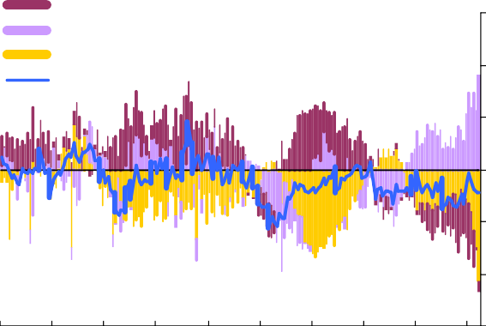

Percentage of nominal

Private: Households Private: Corporates General government

External

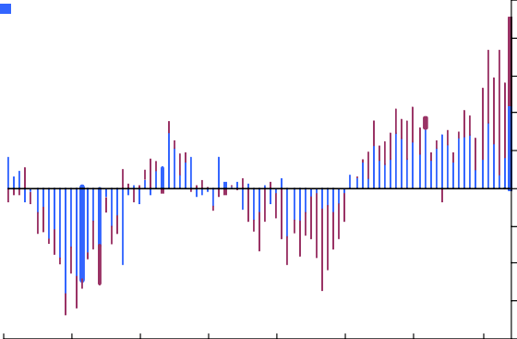

Financials

Private non-financials

Percentage of nominal G

15 10

8

10

6

5 4

2

0

0

-5 -2

-4

-10

-6

-15 -8

1963 1968 1973 1978 1983 1988 1993 1998 2003 2008 1987 1990 1993 1996 1999 2002 2005 2008

Source: ONS. Source: ONS.

# Chart 3: Capital gearing for UK households Chart 4: Capital gearing for UK PNFCs

Per cent

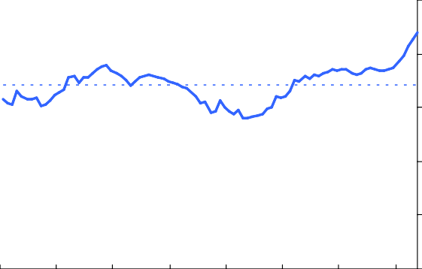25

20

15

10

5

Per cent

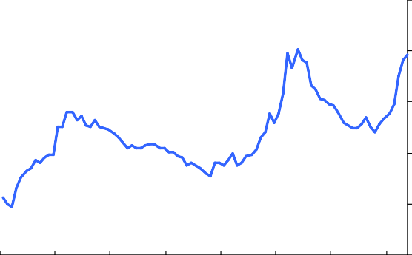50

40

30

20

10

0

1987 1990 1993 1996 1999 2002 2005 2008

Source: ONS.

(a) Capital gearing is the ratio of households' gross financial debt to their gross wealth (financial assets and housing wealth).

0

1987 1990 1993 1996 1999 2002 2005 2008

Source: ONS.

(a) Capital gearing is the ratio of firms’ net debt to their market value.

# Chart 5: Income gearing for UK households Chart 6: Contributions to change in UK

**household sector capital gearing**

Per cent

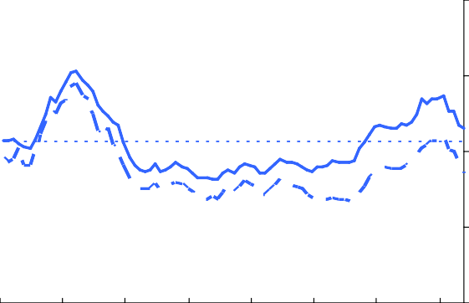20

15

10

5

Percentage change on previous year

20

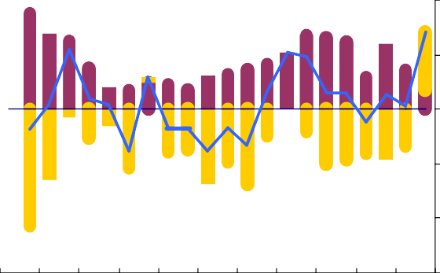

Capital gearing

Liabilities

Assets

10

0

-10

-20

0

1987 1990 1993 1996 1999 2002 2005 2008

Source: ONS.

87 89 91 93 95 97 99 01 03 05 07

Sources: ONS and Bank calculations.

-30

(a) Income gearing is the ratio of household interest and regular repayments of mortgage principal to post-tax income (dashed line shows gearing excluding principal repayments).

(a) Contributions are approximations based on change in logs.

# Chart 7: Household wealth Chart 8: Household debt

ncome 1200

Percentage of i

Net Worth

Gross Wealth

1000

800

600

400

200

0

Per cent

200

180

160

140

120

100

80

60

40

20

0

87 91 95 99 03 07 1987 1990 1993 1996 1999 2002 2005 2008

Source: ONS and Bank calculations. Source: ONS and Bank calculations.

# Chart 9: NMG debt to income ratios by age group

**Chart 10: NMG mean debt by age group**

tio 2.5

2004

2005

2006

2007

2008

Ra

2.0

1.5

1.0

0.5

0.0

2004

2005

2006

2007

2008

Current prices

80,000

70,000

60,000

50,000

40,000

30,000

20,000

10,000

0

18-24 25-34 35-44 45-54 55-64 65+ 18-24 25-34 35-44 45-54 55-64 65+

Source: NMG and Bank calculations. Source: NMG and Bank calculations.

# Chart 11: Current account components Chart 12: Revaluing the International

**Investment Position**

Net investment income Net trade

Percentage of GDP Market value

Percentage of GDP

Other

(a)

4 Book value 20

Current account 3

2

1

0

-1

-2

-3

-4

-5

-6

80 83 86 89 92 95 98 01 04 07

1991 1994 1997 2000

15

10

5

0

-5

-10

-15

-20

-25

-30

2003 2006 2009

Source: Bank of England and ONS.

(a) Overseas transfers such as aid

Source: Bank of England and ONS.